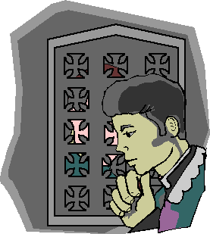
Reconciliation

Follow the directions and fill in the blanks to find out what the message says below.

1. Reconciliation is the sacrament by which sins committed after birth are forgiven through the absolution of the priest. Put a S if it is true. Put a F if it is not.

2. A deacon can also hear confessions and give absolution. Put a A if it is true. Put a O if it is not.

3. An examination of conscious is not needed before confession. Put a N if it is true. Put a R if it is not.

4. In giving absolution, the priest forgives sin. Put a G if it is true. Put a C if it is not.

5. We have to be sorry for our sins or they will not be forgiven. Put a I if it is true. Put a T if it is false.

6. We must firmly resolve to not sin again. Put a V if it is true. Put a T if it is false.

7. The prayers or good works assigned by the priest after one has confessed his sins is called humility. Put a I if it is true. Put a E if it is false.

8. The Sacrament of Reconciliation gives us Sanctifying Grace. Put a N if it is true. Put a F if it is false.

9. If our sins are very serious and we have done them for a long time, they may not be forgiven. Put a Y if it is true. Put a E if it is false.

10. If we have committed mortal sin, the eternal punishment is removed and at least part of the temporal punishment is also removed. Put a S if it is true. Put a N if it is false.

11. We must perform the penance the priest assigns as soon as possible after leaving the confessional. Put a S if it is true. Put a G if it is false.

The main effect of the Sacrament of Reconciliation is the

___ ___ ___ ___ ___ ___ ___ ___ ___ ___ ___ of sins.
1 2 3 4 5 6 7 8 9 10 11

